Homework -8 – March Batch
27th July, 2020

Task 1: Cucumber Setup
Download Cucumber libraries from the maven repository, download the jar file, bring them into your project and add them to build path in your project
https://mvnrepository.com/
cobertura-2.1.1
cucumber-core-1.2.4
cucumber-html-0.2.6
cucumber-java-1.2.4
cucumber-junit-1.2.4
cucumber-jvm-deps-1.0.5
cucumber-reporting-2.7.0
cucumber-testng-1.2.4
gherkin-2.12.2
junit-4.12
mockito-all-1.9.1-20110911
Install Cucumber Plugin from Eclipse Marketplace

Task 2: Answer the following questions
- What is features and step def files in cucumber?
- How to create a feature file, how to add scenarios to the features?
- What is hook, why we use them?
- What is tag, why we use them?
- When we use background?
- How to do data driven testing in cucumber?
- How to create data table in cucumber?
- How to run multiple set of data in a cucumber test?
- How to create a test suite in cucumber?
- How to organize our tests in different test suites for regression, UAT or other purposes?
- What is bdd, and why we use them?
- Why we are using cucumber, how it is better than other test frameworks (TestNG, junit)
- What is glue code in cucumber?
- What is test runner, or how to create a test suite
- How the reports are created in cucumber?

Task 3: Write Test Scripts using BDD Cucumber for creating following tests (you need to create feature file, then implement it in the step definition, create a test suite using test runner class, if required create data table for data driven testing, also create page object model for each page you are testing.
- Test the title and URL of all the links in the footer of the page
http://automationpractice.com/index.php
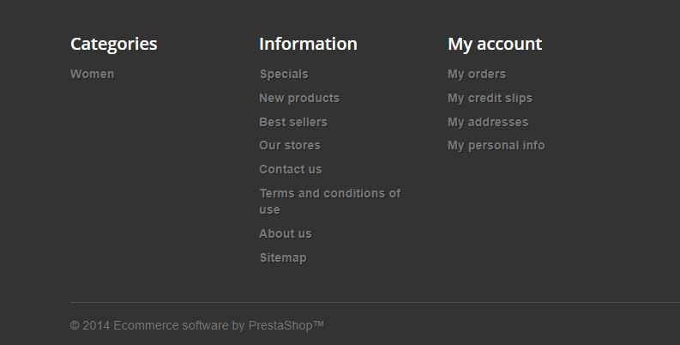

You need to click in each link and then validate the title of the page, after each step you need to come back to the home page and click again to the new link.
- Create a data driven testing for the following registration module, use cucumber data table to create the test
https://login.yahoo.com/account/create
- Create multiple test runner using junit and run all the tests, sets of few tests together and generate reports.

